Name: __________________________

Body Biography
(The Hunger Games Part I Summative)

You will be creating a Body Biography--a visual and written portrait illustrating several aspects of a character's life within the novel. Choose a major character from Part I of The Hunger Games. You may use the novel for help.
Use the template provided or your own drawing to create an outline of your character’s body. Choose colors, graphics, designs carefully so that they represent who your character truly is.
Place and label the following elements on your body:
- Heart: What represents the heart of the person and where should it be placed to identify what the person loves most? What should it look like and what shape, color, pictures, or symbols should be included?
- Eyes: Where is this person’s focus? What does this person see?
- Backbone: What motivates this person the most? What gives them strength?
- Hands: What does this person hold in their hands – literal and figurative?
- Feet: On what foundation is this person standing? What are their fundamental life beliefs?
- The Background: what elements make up this person’s environment/background
- Quotations: Select 3 or more quotations by or about this person that you feel represent them
- Virtues and Vices: Admirable and unadvisable qualities of this person
- Original Text: Create an original text that helps understand this person and include it somewhere appropriate on the body biography.
  - Formula poem, free-verse or rhyming poem, two-voice poem, paragraph, etc.

**Write an explanation beside each element on your body biography.

Example from Flowers for Algernon

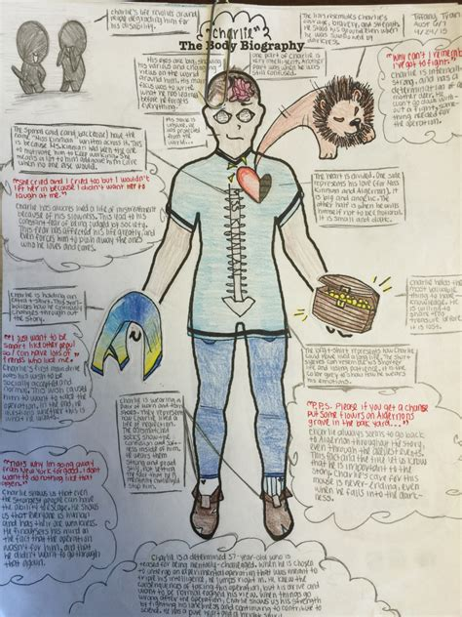

Choices for Orginal Text:

I Am (as if the character were speaking)
1st Stanza
I am (two special characteristics the character has).
I wonder (something the character is curious about).
I hear (an imaginary sound).
I see (an imaginary sight)
I want (an actual desire).
I am (the first line of the poem repeated).

2nd Stanza
I pretend (something the character pretends to do).
I feel (a feeling about something imaginary).
I touch (an imaginary touch).
I worry (something that really bothers the character).
I cry (something that makes the character very sad).
I am (the first line of the poem repeated).

3rd Stanza
I understand (something the character knows is true).
I say (something the character believes in). I dream (something the character dreams about).
I try (something the character really make an effort about).
I hope (something the character hopes for).
I am (the first line of the poem repeated).

Name Poem (or, Acrostic Poem): Write the letters of the character’s first and last names in a column. Using words that begin with the letters of the name [and even the name itself if you want], write a poem that describes the character. Play with words until the poem looks, sounds, and feels right.

Where I’m From (George Ella Lyon poem as a model): Focus on how your character would write this poem.

Where I'm From
I am from clothespins,
from Clorox and carbon-tetrachloride.
I am from the dirt under the back porch.
(Black, glistening,
it tasted like beets.)
I am from the forsythia bush
the Dutch elm
whose long-gone limbs I remember
as if they were my own.
I'm from fudge and eyeglasses,
from Imogene and Alafair.
I'm from the know-it-alls
and the pass-it-ons,
from Perk up! and Pipe down!
I'm from He restoreth my soul
with a cottonball lamb
and ten verses I can say myself.
I'm from Artemus and Billie's Branch,
fried corn and strong coffee.
From the finger my grandfather lost
to the auger,
the eye my father shut to keep his sight.
Under my bed was a dress box
spilling old pictures,
a sift of lost faces
to drift beneath my dreams.
I am from those moments--
snapped before I budded --
leaf-fall from the family tree.

